**Family Tree:**

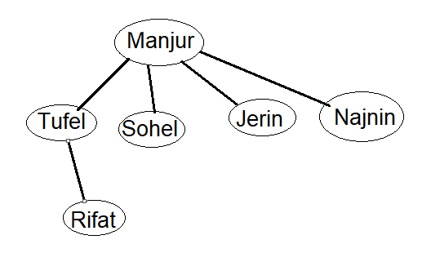

**Tables:**

**Parent Table:**

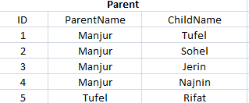

**Male Table:**

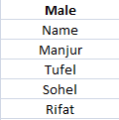

**Female Table:**

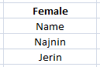

**Tables on Server:**

**Parent1:**

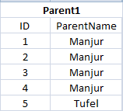

**Male1:**

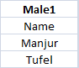

**Female1:**



**Tables on Site:**

**Parent2:**

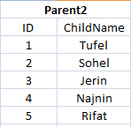

**Male2:**

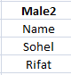

**Female2:**

